Literacy support worksheet

7.1 The human body is divided into systems

Pages 116–117 and 203

Human body systems

1 On the lines to the right of each diagram, list the organs involved in each system using the list below.

|  |  |  |  |  |  |
| --- | --- | --- | --- | --- | --- |
| *Brain* | *Nose* | *Muscles* | *Blood* | *Stomach* | *Mouth* |
| *Lungs* | *Small intestine* | *Heart* | *Diaphragm* | *Oesophagus* | *Large intestine* |
| *Liver* | *Veins* | *Spinal cord* | *Windpipe* | *Bones* | *Nerves* |
|  | |  | |  | |
| SKELETAL SYSTEM | | NERVOUS SYSTEM | | CIRCULATORY SYSTEM | |
|  | |  | |  | |
|  | |  | |  | |
| RESPIRATORY SYSTEM | | DIGESTIVE SYSTEM | | MUSCLE SYSTEM | |

2 Draw a flowchart that depicts the pathway from cells to body systems.

3 The first scientists lived in Alexandria during what time?

4 Why did they perform dissections?

5 What is involved in the Ancient Egyptian process of mummification?

6 What was da Vinci able to model from his investigations of the heart?

7 List three advances that occurred due to the improvement in medical care in the 1700s.

Word detective

8 Secret message

Use words from the Student Book to work out the secret message.

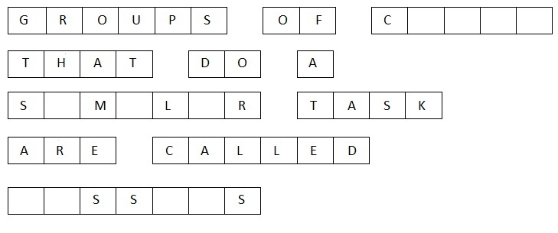

T_____________ are made of groups of _______________ that do a similar job, and groups of

_________________ that work together are called o___________________.

Literacy support worksheet

7.2 The digestive system is made up of organs

Pages 118–119 and 204–205

The digestive system

1 What is digestion?

2 Nutrients are substances that provide nourishment. How are nutrients transported through the body?

3 Enzymes break down food in the mouth. What sort of digestion is this?

4 A biting motion also breaks down food in the mouth. What sort of digestion is this?

5 Label the following diagram of the mouth, and state the function of each type of tooth.

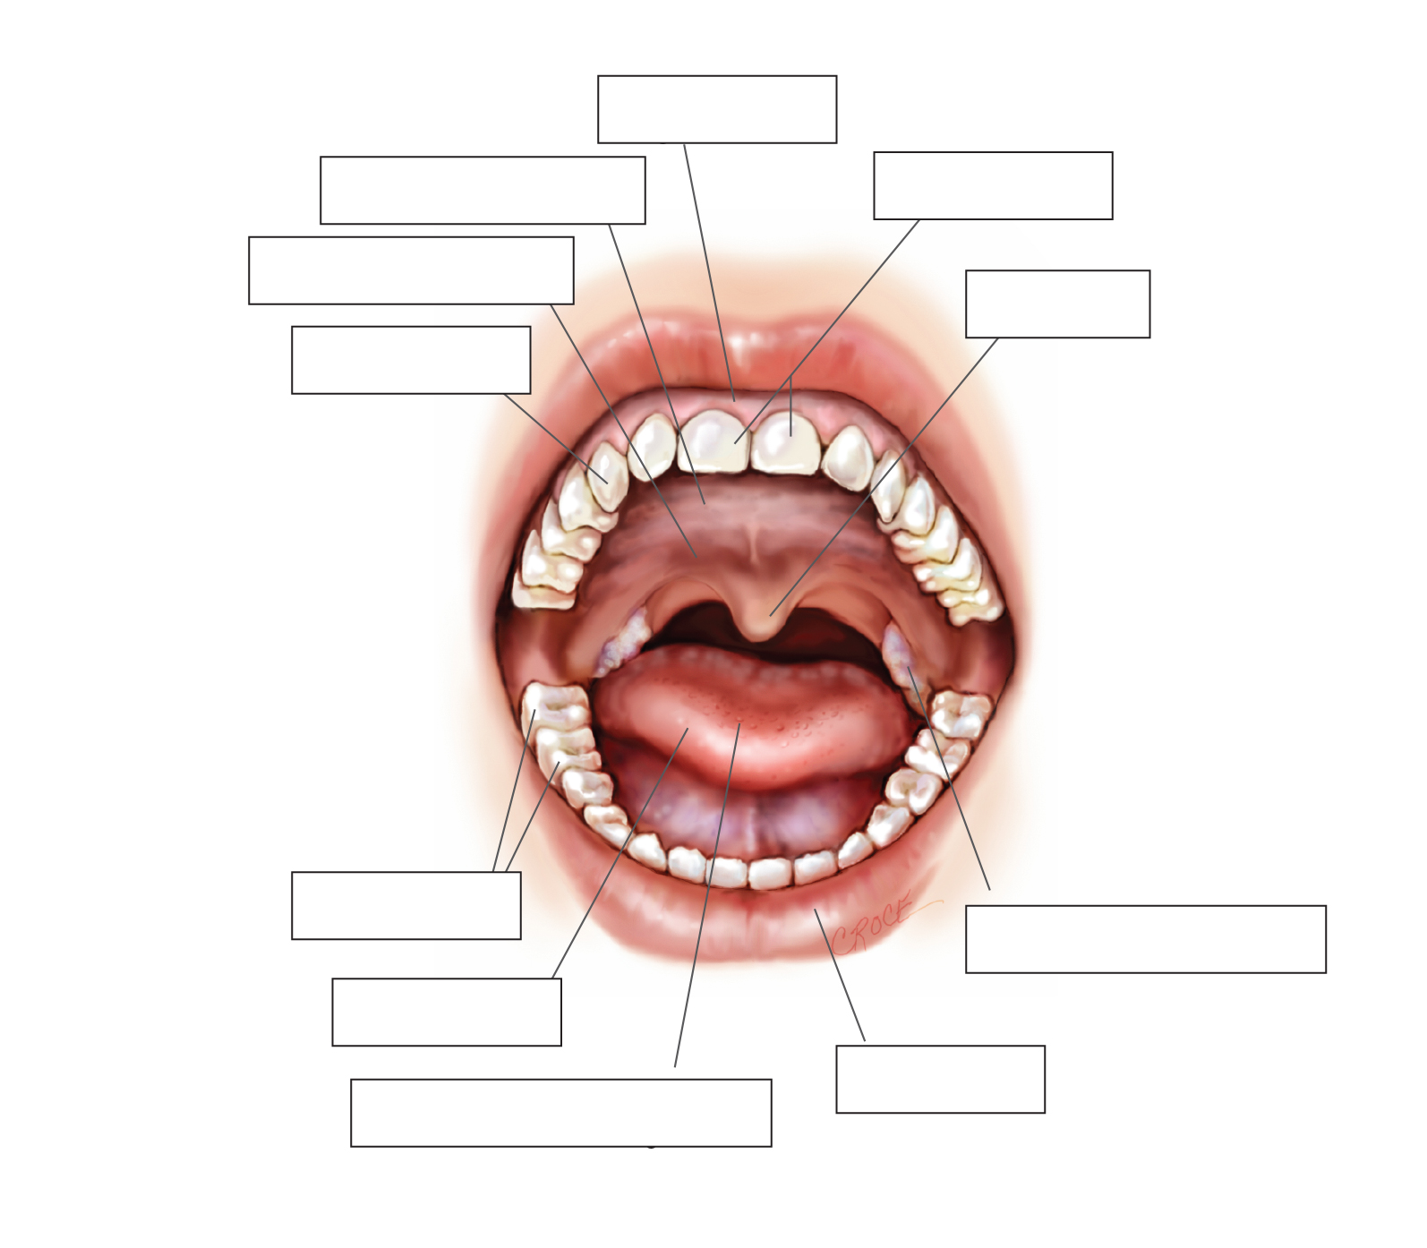

6 Label the following diagram of the digestive system.

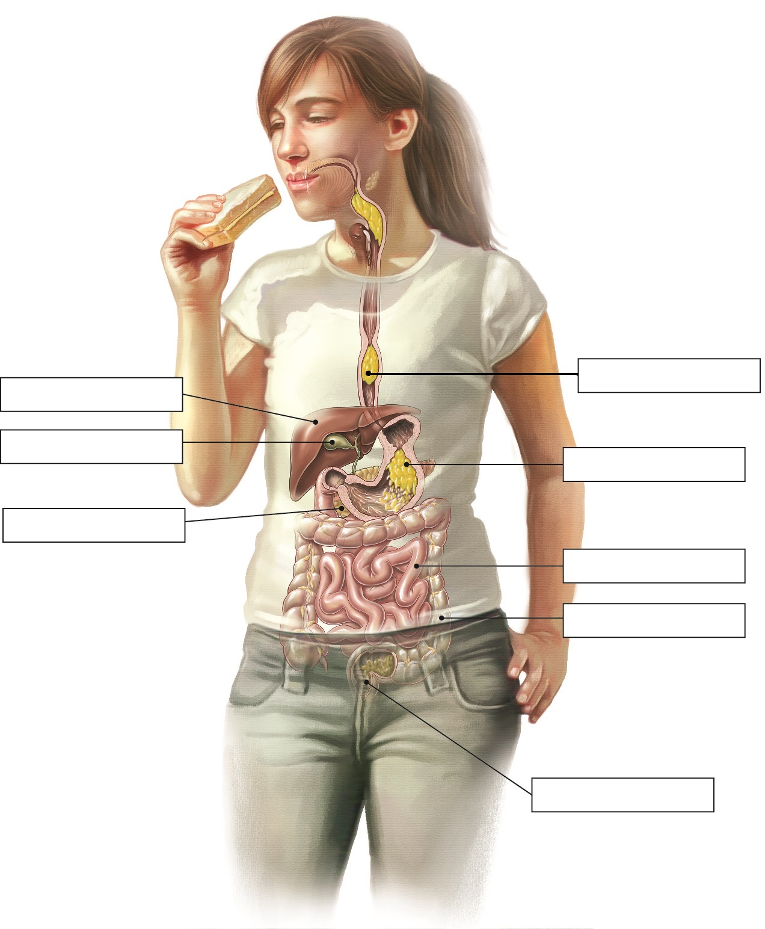

Word detective

7 Matching meaning

Draw a line to match the organ (on the left) with the appropriate description of its function (on the right).

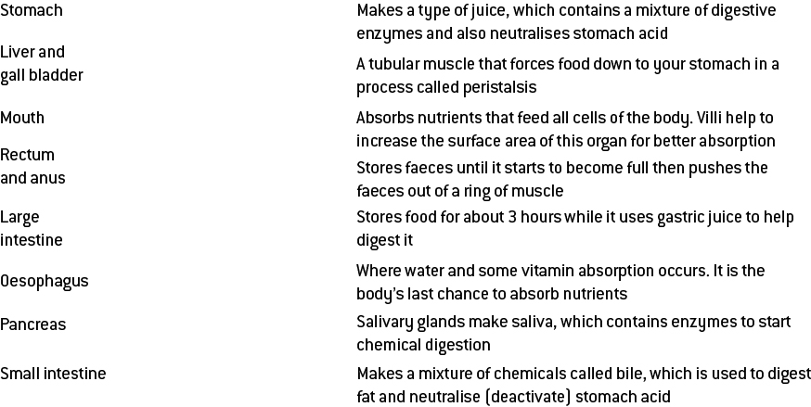

Literacy support worksheet

7.3 The digestive system varies between animals

Pages 120–121

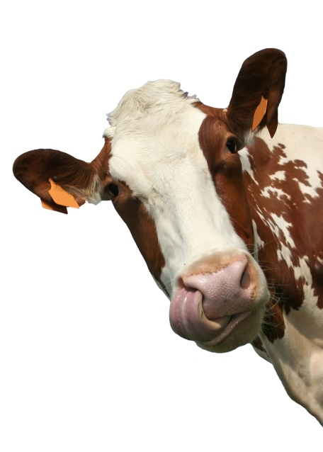The digestive systems of various animals

1 Describe each of the different types of teeth:

a Incisors

b Canine teeth

c Molars

2 How would a palaeontologist know what an animal from the past ate?

3 What lives in the caecum?

4 Why is this organism needed?

5 Draw a diagram of a cow’s digestive system:

6 What is a ruminant?

7 What other animals are ruminants?

8 Using the information on page 121 of your student book and your knowledge of the function of digestive organs, match the organ involved in a cow’s digestive system with its function.

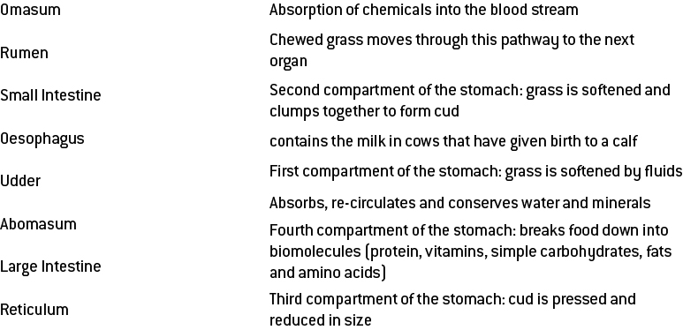

Word detective

9 Order us!

The following sentences describe the process of a cow’s digestion. Place them in the correct order, by writing a number from 1 to 5 beside each one.

_____ Abomasum – has acid and enzymes like a human stomach

_____ Rumen – grass is swallowed and goes here.

_____ Reticulum – involved in trapping any unwanted things the cow may have swallowed

_____ The grass is regurgitated and is chewed over and over again.

_____ Omasum – has many leaf-like folds that filter fine particles

Literacy support worksheet

7.4 Things sometimes go wrong in the digestive system

Pages 122–123

Problems in the digestive system

Stomach ulcers

1 In which digestive organ do stomach ulcers form?

2 What is the name of the bacteria that causes of stomach ulcers?

3 How do patients feel when they have a stomach ulcer and why?

Gallstones

4 Finish the sentence:

Occasionally parts of the bile harden into a small stone that stops

5 What effect does a gallstone have on your body?

6 What are three treatments for gallstones?

Gluten intolerance

7 What are the symptoms of gluten intolerance?

8 What is gluten intolerance?

9 Which parts of the body can gluten intolerance affect?

10 What is the treatment for gluten intolerance?

Constipation

11 Which part of the body is blocked when constipation occurs?

12 What effect does constipation have on your body?

13 What is the treatment for constipation?

Word detective

14 Crossword

Read the clues and fill in the crossword below.

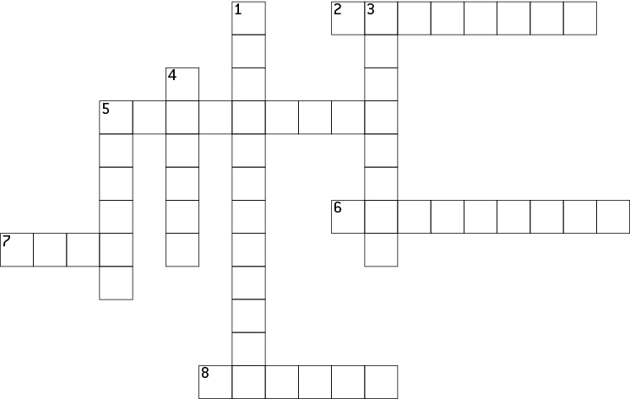

**Across**

2 A type of organism that causes ulcers

5 A small stone that stops the bile from leaving the gallbladder

6 Watery faeces

7 The gallbladder stores this substance

8 Found in saliva to assist chemical digestion

**Down**

1 When the large intestine becomes blocked

3 When the body’s immune system fights against a food

4 Small open sores in the stomach lining

5 A small molecule found in many cereals and grains

Literacy support worksheet

7.5 The respiratory system exchanges gases

Pages 124–125 and 206

The respiratory system

1 What is the role of the respiratory system?

2 What is the process of using oxygen to release energy in cells called?

3 How is oxygen transported to the lungs? Draw a horizontal flow diagram to show this:

4 What are the alveoli?

5 Draw and label diagram of how the trachea, bronchi, bronchiole and air sacs (alveoli) look together. Use figure 7.9 in Oxford Science 8 to help you.

6 What is the diaphragm?

7 What do the muscles in the diaphragm do when you:

a breathe in (inhalation)

b breathe out (exhalation)

8 Label the following diagram of the respiratory system.

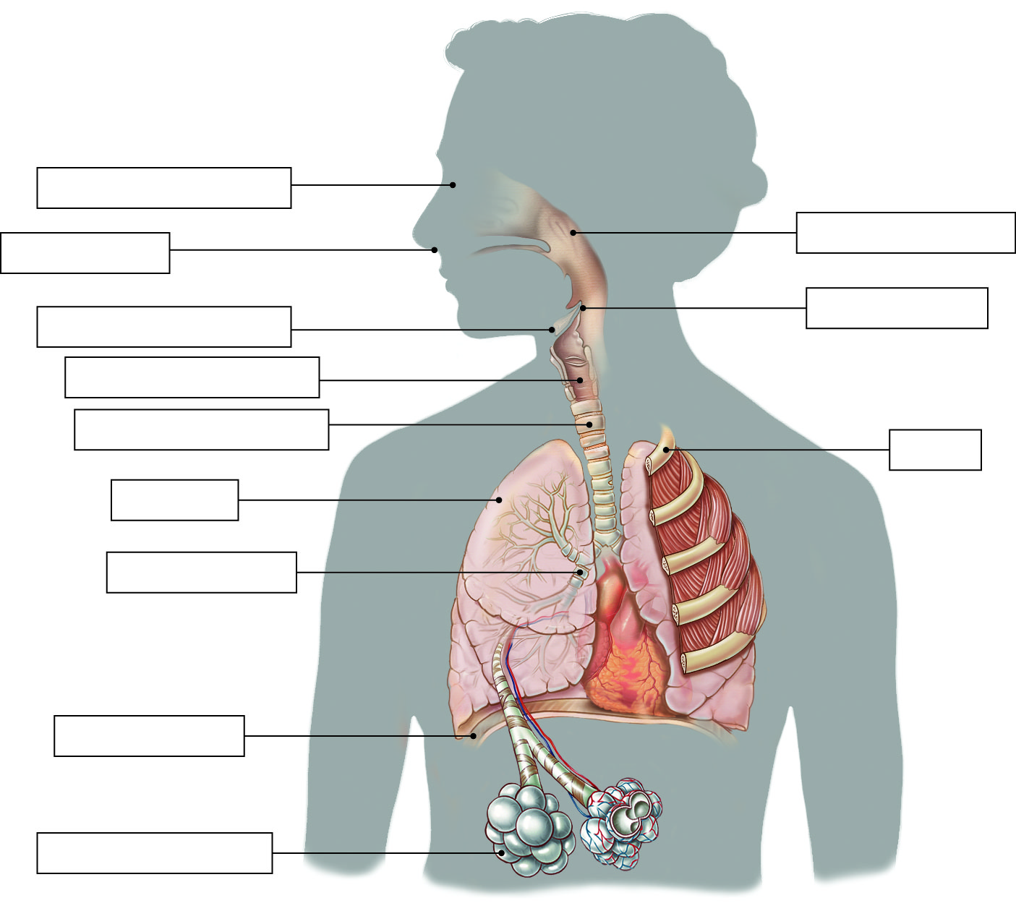

Word detective

9 Draw and label.

Draw and label a diagram of the capillaries. Use figure 7.19 from *Oxford Science 8* to help you. Include the following labels:

* Oxygen moves from air to blood.
* Blood from body contains carbon dioxide.
* Carbon dioxide moves from blood into air.
* Blood contains oxygen, moves into body.

|  |
| --- |
|  |

Literacy support worksheet

7.6 Things sometimes go wrong in the respiratory system

Pages 126–127

Problems in the respiratory system

Coughing and sneezing

1 Name four things that can go wrong with the respiratory system:

2 In which respiratory organ does coughing and sneezing occur?

3 What is the cause of coughing?

4 Draw a flow diagram showing how the brain registers a sneeze and where the message goes:

Brain

5 How fast are some sneezes?

Asthma

6 How many Australians are affected by asthma?

7 In which respiratory organ does asthma occur?

8 Draw a quick flow diagram outlining how asthma is caused and the flow on effects:

9 What is the treatment for asthma?

Emphysema

10 What is the main cause of emphysema?

11 What effect does emphysema have on your body?

12 What is a treatment for emphysema?

Pneumonia

13 What is the cause of pneumonia?

14 What effect does pneumonia have on your body?

15 What is the treatment for pneumonia?

Word detective

16 Fill in the gaps

Fill the gaps in the sentences below, using the words provided.

throat cilia

chest particles

diaphragm nose

bronchioles cells

Every time you breathe in, you take in small particles of dust, pollen and other ___________________.

Small ___________________ on the surface of the ___________________ trap these particles and push

them to the top of the ___________________ where they are swallowed. Larger particles trigger the

___________________ making us cough. This pushes up the large particle before it enters the

___________________. Sneezes happen when particles get trapped by the hairs in our

___________________. A message is then sent to the brain which controls the muscles in the eyes,

___________________, stomach and diaphragm, making us sneeze.

Literacy support worksheet

7.7 The circulatory system carries substances around the body

Pages 128–129 and 207

The circulatory system

1 What does the circulatory system do?

2 What is the heart?

3 How many chambers are there in a human heart?

4 Label the diagram of the heart and draw arrows to show how the blood flows through each part. 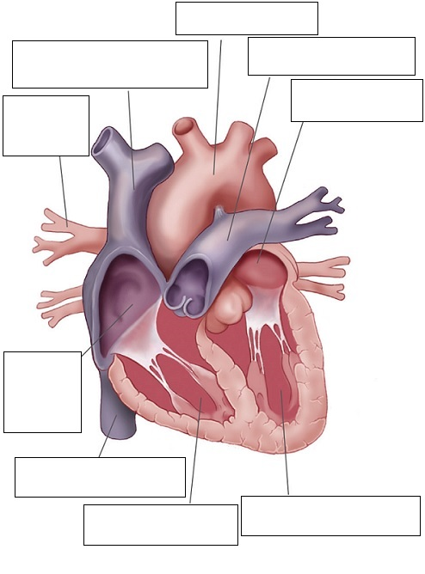

5 What are the top chambers called?

6 What are the bottom chambers called?

7 Which side pumps blood to the lungs?

8 Which side pumps blood around the body?

9 Draw a line to match each component of blood, from the words on the left, to its function, on the right.

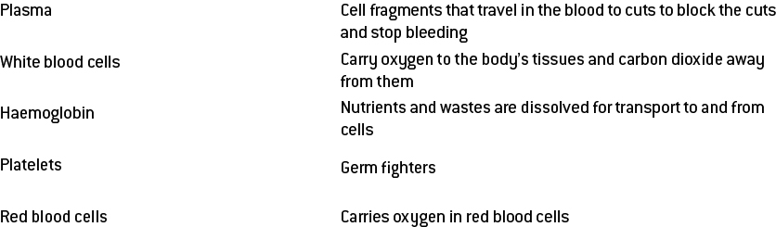

10 Which type of blood vessel carries blood toward the heart?

11 Which type of blood vessel carries blood away from the heart?

12 Why do capillaries have cell walls that are only one cell thick?

13 What do the capillaries connect to?

Word detective

14 True or false

Read the statement and circle whether it is true or false.

a The heart is about the size of your fist. T or F

b Valves keep the blood moving in the right direction. T or F

c Oxygen is carried by white blood cells. T or F

d Red blood cells kill bacterial cells. T or F

e Platelets are cell fragments that fix blood vessels. T or F

f Capillaries are the largest blood vessels. T or F

g Arteries are only one cell thick. T or F

Literacy support worksheet

7.8 Things sometimes go wrong in the circulatory system

Pages 130–131 and 208

Problems in the circulatory system

Valve disease

1 What are three ways that the heart valves can become damaged?

2 What are the effects of valve disease?

3 What is a symptom of valve disease?

Atherosclerosis

4 In which cardiovascular organ does atherosclerosis occur?

5 What is the cause of atherosclerosis?

6 Name three things that plaque consists of.

7 What effect does atherosclerosis have on your body?

Coronary heart disease

8 What is the cause of coronary heart disease?

9 What effect does coronary heart disease have on your body?

10 What are two ways to avoid coronary heart disease?

Pericarditis

11 What is the pericardium?

12 What is the cause of pericarditis? Finish the sentence below.

When the pericardium becomes

13 What effect does pericarditis have on your body?

Word detective

14 Draw and label

Draw and label a diagram of a blocked artery and a dying heart muscle. Use Figure 7.31 from *Oxford Science 8 Western Australian Curriculum* to help you. Include these labels:

Artery Blood clot

Coronary arteries Healthy muscle

Dying muscle

Literacy support worksheet

7.9 The excretory system removes waste

Pages 132–133 and 208

The excretory system

1 What does the excretion system do?

2 Name the organs of excretion.

3 Why is water important in controlling wastes?

4 Label the organs involved in the excretory system.

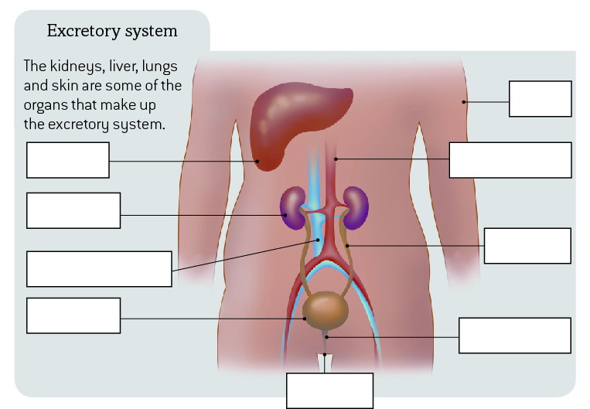

5 Label the main parts of a kidney below.

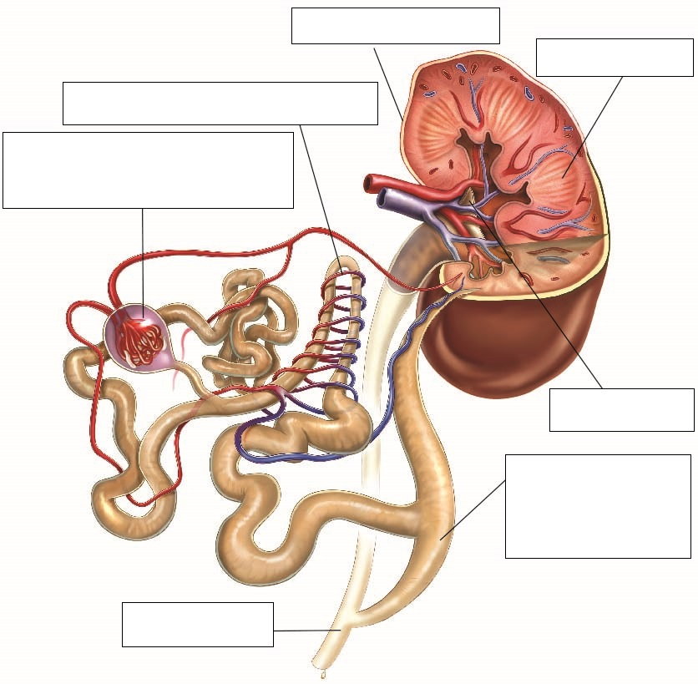

6 Describe the body’s five step process to digest (metabolise) proteins:

a

b

c

d

e

7 What does the liver do in the excretory system?

Word detective

8 Boggle

Find and circle as many words as you can about the excretory system in the puzzle below.

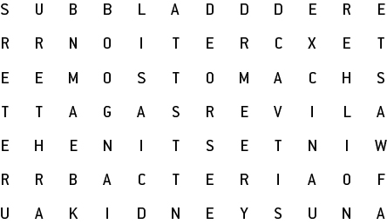

Literacy support worksheet

7.10 Plants have tissues and organs

Pages 134–135 and 209-210

Plant systems

1 Name three specialised organs found in plants:

2 Name three functions of roots.

3 What is the role of the stem in a plant?

4 What is the function of leaves in a plant?

5 What is the role of the vascular bundle in the stem?

6 Label the vascular bundle below. Use Figure 7.41 in *Oxford Science 8 Western Australian Curriculum* to help you.

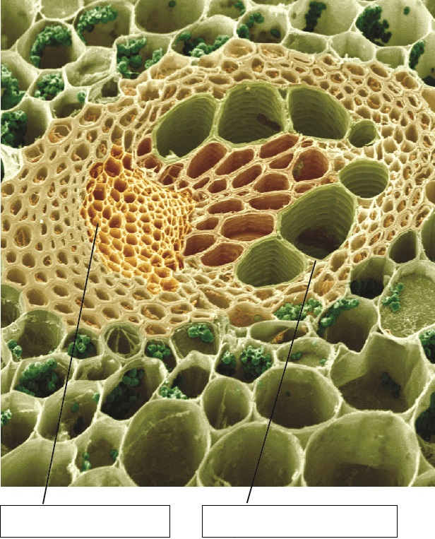

7 Label the stoma below.

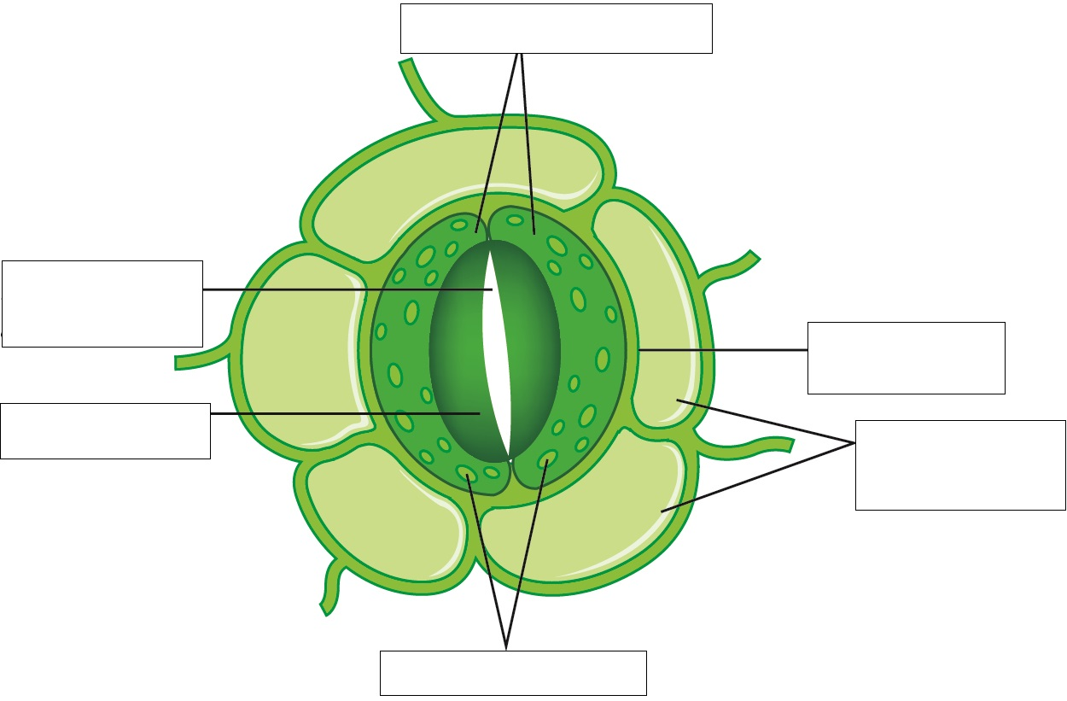

8 What moves in and out of the cells through the stomata?

9 How do the guard cells of the stomata stop the plant from losing too much water?

Word detective

10 Order us!

Number each of the sentences below to place them in order, showing the correct sequence of what happens in the osmosis process in roots.

______ The inside of the roots become more salty than the soil.

______ Water molecules are attracted to the mineral salts in the root cells.

______ Roots take in mineral salts from the soil.

______ Water moves through the root cell membrane and into the plant.

______ Roots store the mineral salts in their cells.